Modeling Exchange Rate Stochastic Volatility

Sathish Komire, Adam Messina, Siddharth Maredu

2024-03-11

**Abstract**

Exchange rates between different currencies fluctuate every day, making it difficult to know exactly how volatile they will be in the future. Stochastic volatility models utilizing the state-space framework can be used to forecast future volatility. These models are commonly used for financial time series and can provide useful insight for future risk. These models can be achieved by utilizing the stochvol package in R to obtain the log variance of time series and forecast the future stochastic volatility by utilizing Bayesian inference.

**Introduction**

The stochastic volatility (SV) model is a state-space model, commonly used for financial time series, that uses Bayesian inference and allows for heteroskedastic modeling. The model obtains draws from the posterior distribution of parameters and latent variables and is used to predict future volatilities. The model takes in a random vector of returns with mean zero, where each observation has its own variance denoted as e^ht. The variance does not vary unrestrictedly with time, but its logarithm is assumed to follow an autoregressive process of order one. The model is expressed in hierarchical form given through the centered parameterization below:

N (µ, σ2 η ) denotes the normal distribution with mean µ and variance σ2 η. Theta is referred to as the vector of parameters (θ = (µ, φ, ση) ^T), where µ refers to the level of log-variance, φ refers to the persistence of log-variance, and ση refers to the volatility of the log-variance. The process h = (h0, h1, . . . , hn) is an unobserved and interpreted as the log-variance process or time-varying volatility process.

The dataset we have chosen is Foreign Exchange rates (daily updates) - Daily time series of FX rates from Kaggle (<https://www.kaggle.com/datasets/konradb/foreign-exchange-rates-daily-updates>). This dataset contains daily FX rates for the major currencies provided by Yahoo finance. We have chosen specifically to work on USDINR_Close for our univariate time series forecasting using stochvol package from R. It's imperative that we use stochvol because SV models treat volatility as a latent stochastic process. This allows for a more flexible representation of volatility dynamics, capturing the volatility clustering phenomenon inherent in financial time series. We chose to work with the years of 2017- 2021 to forecast the volatility. The head of the data and a time series graph is provided below:

## # A tibble: 6 × 2  
## Date USDINR_Close  
## <date> <dbl>  
## 1 2017-01-02 67.9  
## 2 2017-01-03 68.1  
## 3 2017-01-04 68.3  
## 4 2017-01-05 67.9  
## 5 2017-01-06 67.7  
## 6 2017-01-09 68.1

plot(df$Date, df$USDINR_Close, type = 'l', main = 'USD/INR Closing Prices')

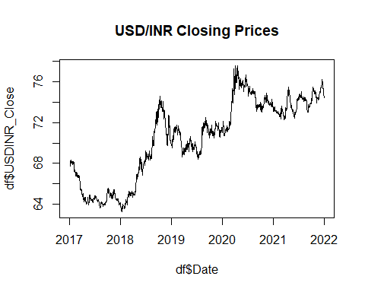

**Method**

We are using the stochvol package in R to compute stochastic volatility. Within this package you can simulate data with the function svsim(). This function includes parameters including length of simulated values and mu, phi, sigma parameters to generate data as specified below.

library(stochvol)

## Warning: package 'stochvol' was built under R version 4.2.3

sim <- svsim(500, mu = -9, phi = 0.95, sigma = 0.15)  
par(mfrow = c(2, 1))  
plot(sim)

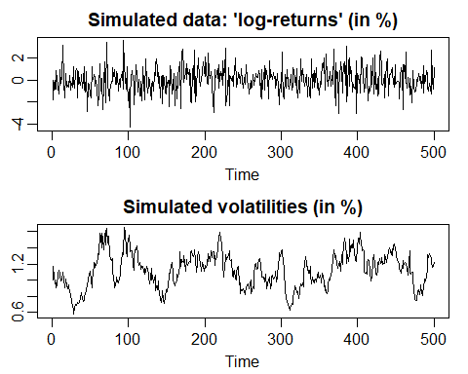

After simulating the data, we ran it through the model using the function svsample(). This model includes a parameter for the log-returns and the priors. The prior parameters include priormu, priorphi and prior sigma.

Here, priorphi can be tuned by adjusting the values of a0 and b0.



Fig.1

In Bayesian inference, setting priorphi close to 1 signals the expectation of high volatility persistence; values closer to 0 suggest lower persistence, indicating that volatility changes are less influenced by their immediate past.

Our belief of persistence in this iteration of simulation is high, therefore we tuned our priorphi is equal to 0.95 which is close to 1 by setting a0=39 and b0=1.

res1 <- svsample(sim, priormu = c(0, 100), priorphi = c(39, 1),  
 priorsigma = .15)

## Extracted data vector from 'svsim'-object.

## Done!

## Summarizing posterior draws...

After the model was trained, we put it through the volplot() function to obtain the forecasted volatility values. This includes parameters for inputting the result from svsample, defining the amount of data points to forecast and then dates to define the x plot of the graph.

volplot(res1, forecast = 50)

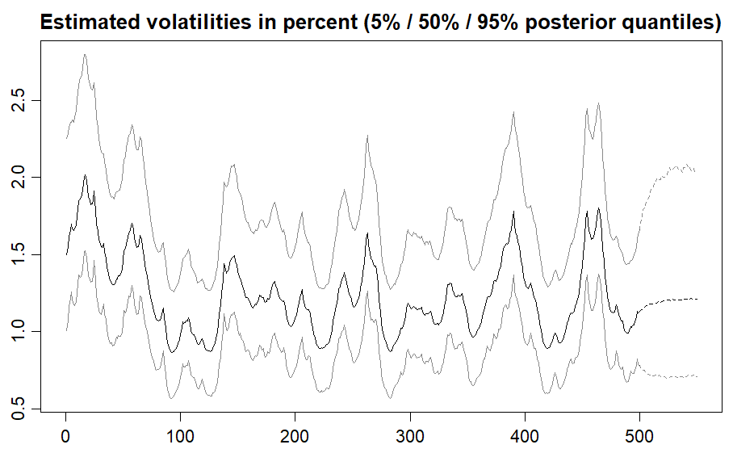

After generating the volplot, we have produced the plots for the simulated data capturing the estimated volatilities of the posterior quantities mentioned within the ranges below.

The distribution of the posterior shows volatility as indicated by the crests and troughs in the data which is described by the choice of hyperparameters mu, phi and sigma.

The top dashed line: the 95% quantile, suggesting that the actual volatility is expected to be lower than this line 95% of the time.

The solid middle line: the median or 50% quantile, providing a central estimate of the volatility.

The bottom dashed line: the 5% quantile, indicating that the actual volatility is expected to be higher than this line 95% of the time.

The shaded area between the dashed lines represents the uncertainty or the range of likely values for the volatility. Peaks in the plot represent periods of high estimated volatility, which might correspond to events or movements in the market increasing uncertainty. The forecasted values, as indicated by the lighter dashed line extending to the right, show predictions of future volatility based on the model. These forecasts are essential for risk management and financial decision-making.

plot(res1, showobs = FALSE)

## Simulation object extracted from input

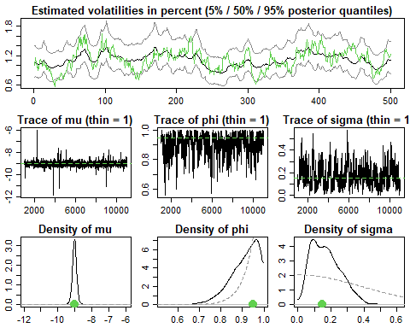

The choice of mu has little significance on the posterior draws so is the standard deviation due to large number of observations in the data.

The most significant parameter is phi which determines persistence of the plot are tuned by the hyperparameters a0 and b0 in the vector priorphi. These hyperparameters are used to evaluate the expected value of priorphi as described by the expression. Refer( Fig 1)

If it’s closer to 1 it indicates that shocks to volatility have a long-lasting effect, if its closer to 0, it suggests that shocks dissipate more quickly effectively meaning that its not persistent. So, effectively reducing a0 and increasing b0 makes the sv draws more persistent.

res2 <- svsample(sim, priormu = c(0, 100), priorphi = c(15, 10),  
 priorsigma = .15)

## Extracted data vector from 'svsim'-object.

## Done!

## Summarizing posterior draws...

volplot(res2, forecast = 50)

Trace plots for the parameters mu, phi, and sigma indicating, effective MCMC sampling, crucial for credible inferences. The density plots reveal the posterior probability distributions, showing where our parameter estimates are most likely to fall, with phi indicating strong persistence in volatility, as most of its distribution is close to 1.

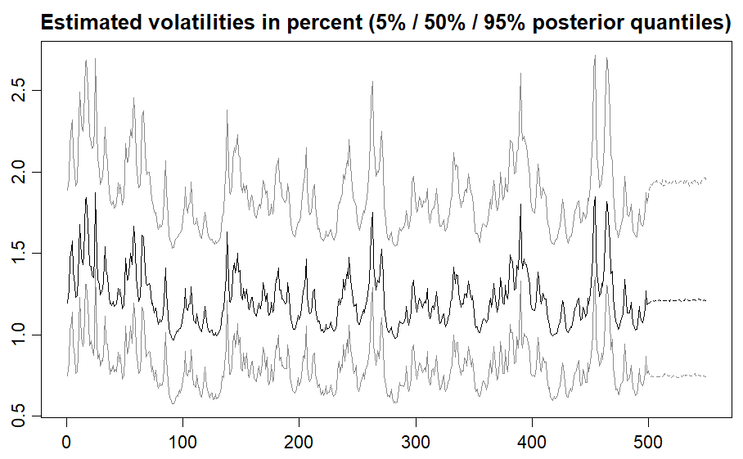

Here, Volatility plot shows that adjusting the priorphi hyperparameter has a notable impact on the inferred volatility profile. We set our our priorphi closer to 0.22 which is closer to 0 indicates an expectation of frequent changes in volatility, independent of recent trends, which results in a plot with more pronounced fluctuations. This exercise underscores the critical role of carefully chosen prior assumptions in shaping the outcomes of a Bayesian stochastic volatility model.

plot(res2, showobs = FALSE)

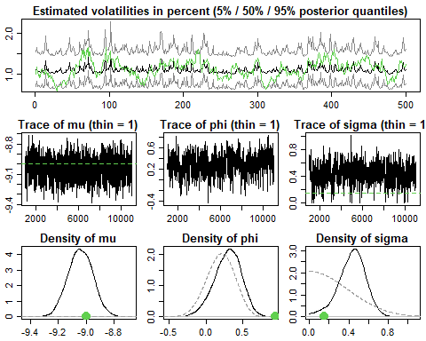## Simulation object extracted from input

Now these trace plots have low noise, indicating good mixing and convergence of the MCMC sampler, with the phi parameter's trace hovering around lower values in line with our low persistence assumption. Correspondingly, the density plot for phi peaks near 0, affirming our prior belief that volatility changes are likely to be frequent and not strongly dependent on past levels. The density plots for mu and sigma depict the spread and uncertainty of these parameters.

**Application**

So, as per our understanding from the Bayesian Inference of our simulation data, among all the hyperparameters, persistence (priorPhi) influences the model more comparatively than other prior beliefs, assuming higher persistence will lead to higher volatility in the forecasting and conversely assuming lower priorphi closer to zero will results in lower volatility of the model forecasting, therefore we choose the persistence somewhere in the middle neither too close to zero nor too close to one.

priorMu essentially sets a baseline expectation for the average level of volatility unless the data is compelling. Since the model gets most of it’s influence from the likelihood rather than mu parameter, the choice of hyperparameters is rather uninformative.

A smaller value for priorSigma would suggest that the fluctuations in volatility are expected to be gentle and consistent over time, resulting in smoother forecasts. A larger value implies anticipation of more dramatic shifts in volatility, allowing the model to adapt quickly to large market moves. If priorSigma is not set to small, it has very minor influence on the model.

Since mu and sigma don’t have that much influence, we choose them arbitrarily. Phi is the most influential, and since we didn’t observe much persistence of volatility in the historical data, we choose the following hyperparameters which result in a moderate phi value:

a0=10 and b0=2

ret = logret(na.omit(df$USDINR_Close), demean = T)  
res3 <- svsample(ret, priormu = c(0, 100), priorphi = c(10, 2), priorsigma = .1)

## Done!

## Summarizing posterior draws...

volplot(res3, forecast = 180, dates = df$Date[-1])

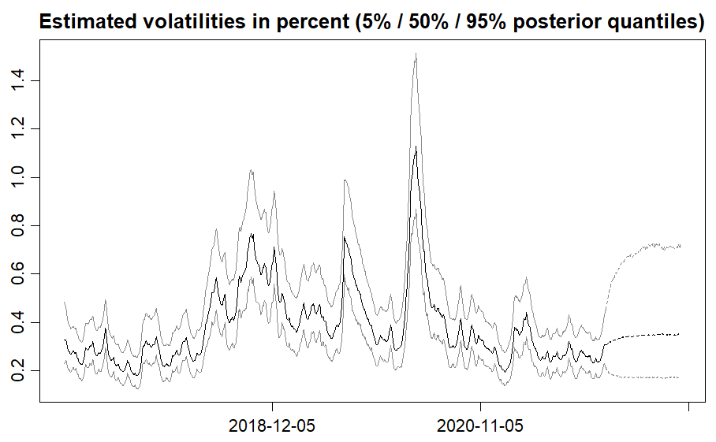

The volatility plot quantitatively depicts the fluctuating uncertainty in a forex USDINR over time. The median estimated volatility is traced by the solid line, representing the 50th percentile of the predictions. The outer dashed lines reflect the 5th and 95th percentiles, creating a confidence interval. Sharp peaks, particularly the pronounced spike near the end of 2021, indicate periods where volatility is high and thus increase in uncertainty.

plot(res3, showobs = FALSE)

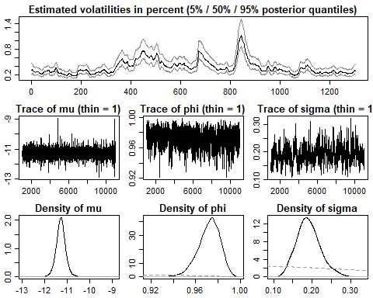

The traceplots depicts the plots for mu, phi and sigma illustrating MCMC sampling paths with each plot showing the value of the parameter at each iteration of the sampling. Indicating good mixing and convergence to a stable distribution

The density plots for the same parameters, which represent the posterior distribution or the range of likely values for each parameter after considering the data and the prior information. The mu density is very narrow, indicating a high level of certainty about the mean level of log-volatility. The phi density plot shows a peak close to 1, suggesting a strong belief in high persistence, while the sigma density plot indicates a moderate level of certainty about the volatility of volatility, with most values concentrated in a specific region of the plot.

myresid <- resid(res3)  
plot(myresid, ret)

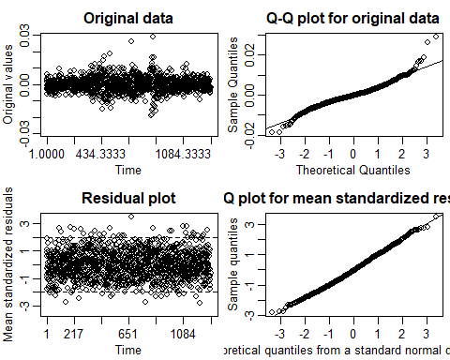

Here we have a plot of the residuals, which are the differences between our actual data points and the model's predictions. We expect to see no clear pattern in a good model, indicating that the model has captured all the predictable information

**Conclusion**

Utilizing this method for forecasting stochastic volatility has its benefits and weaknesses. The stochastic volatility model’s capacity to model randomness is a significant strength. It accurately captures the volatility clustering observed in financial time series especially our foreign exchange rate data. The use of Bayesian inference allows for the incorporation of prior knowledge into the model, providing a framework for integrating market expertise. The stochvol package in R is capable of computing both univariate and multivariate data, which makes it flexible. Although these benefits provide unique value, there are some downsides to utilizing this model and its corresponding package in R. Choosing appropriate prior distributions and model specifications can significantly impact the results of the forecast. This sensitivity necessitates a careful, informed selection process, which might be challenging without substantial prior experience or deep domain knowledge. Because the model will obtain sufficient information from the likelihood function, is not as influential and general hyperparameters can be set. Sigma is less influential as long as its parameter isn’t set too low. Phi is the most influential of the hyperparameters, and not knowing how to tune a0 and b0 accurately is the greatest observed weakness of this model. Regardless of this weakness, the analysis confirmed the presence of volatility clustering in the USDINR exchange rate, providing empirical support for the model's appropriateness. By using the stochvol package, you can generate volatility forecasts and provide valuable insights for future risk management and trading strategies.

References

Kastner, G. (n.d.). Dealing with stochastic volatility in time series using the ... https://cran.r-project.org/web/packages/stochvol/vignettes/article.pdf